Optimized Lightweight Convolutional Neural Network Architecture for Multi-Class Brain Tumor Classification from Magnetic Resonance Imaging
Mahmoud S. Atheeb^{1*}, Baraa I. Farhan²
^{1,2}Department of Computer Science, College of Education for Pure Sciences, Wasit University, Kut, 52001, Iraq
*Corresponding Author: Mahmoud S. Atheeb
DOI: https://doi.org/10.52866/ijcsm.0000.00.00.000
Received 20 January 2025; Accepted 05 March 2026; Available online 30 September 2026
ABSTRACT: A brain tumor classifier from MRI is an important clinical task in modern neuroradiology and has to achieve high accuracy to ensure proper therapy and prognosis. Here we propose a fast and fully automated deep learning architecture with three architectural inventions-the Micro Adaptive Feature Extractor, Micro Multi-Scale Processor and Context-Aware Intelligent Pooling-and present the state-of-the-art parameter-efficient brain tumor classifier. Our optimized model attains a mean classification accuracy of 99.34% (99.22%-99.48% for three independent runs, = 0.11%) across the largest brain tumor MRI dataset to date (Mendeley, 12064 high resolution images, 4 tumor classes glioma, meningioma, pituitary adenoma, no tumor) using merely 659228 trainable parameters. Our system is fully ablated and validated systematically, every new architectural novelty has been validated individually and in combination, with intelligent pooling delivering the maximum 2.18% improvement. Our optimized architecture has been validated numerous times on cross dataset independent test sets, Crushed domain adaptation baselines and achieving state-of-the-art generalization (Kaggle test: 99.24%, Br35H test: 98.33%). Our model is 47x leaner than the state-of-the-art U-Net-based models reaching the highest classification accuracy with only 12 ms of inferences and 2.6 MB of model size, enabling our solution to be introduced on underpowered mobile medical edge devices. These results showed that architecture innovation surpasses models which accumulate too many parameters on medical image classification task.

Keywords: Brain tumor type classification, CNN, MRI image analysis, deep learning, lightweight structure, attention mechanism, medical image processing
©2026 THIS IS AN OPEN ACCESS ARTICLE UNDER THE CC BY LICENSE

- INTRODUCTION
In the field of medical imaging, brain tumor analysis is a relevant topic of research with profound clinical importance considering the pathophysiological effects of brain tumors on survival, neurological function and general health and quality of life, for which diagnosis in a reliable and precocious way is essential to allow sound treatment planning, prognosis prediction and clinical decision making. The imaging modality most frequently used in the study of brain tumors is Magnetic Resonance Imaging (MRI). This is due to its excellent soft-tissue contrast resolution, spatial resolution and images of normal variation for characterizing diseased tissue without use of ionizing radiation. Brain MRI is highly sensitive and specific, but is a time-consuming task to interpret. Tumor masses can vary drastically—even within the same class of tumor—in size, shape, picture course and intensity. Tumors of different classes may have comparable appearances and true visual diagnosis is difficult without software, even more so with inter- and intra-observer variability (diagnostic accuracy of a radiologist is dependent on clinical experience and personal evaluation [1], [2]). In some medical context, the absence of neuroradiology expertise might result in higher diagnostic failure rate and consequently impact on patient outcome. Recently, fast growing of AI and deep learning systems gave a very promising approach for automated image analysis in medicine. Convolutional Neural Networks (CNNs), have already achieved state-of-the-art performance in automatic and unbiased classification of tumors directly from the most discriminative features extracted from raw medical images [1], [3]. Many studies have shown that deep learning algorithms can surpass the performances of expert radiologists/pathologists on medical image classification tasks [4], [ 5] Some of the practical and technical issues remain to be tackled before its adoption in the clinical workflow, such as high model complexity, large model size, poor generalization to independent testing images, lack of small tumor features sensitivity [6], [7].
  - PROBLEM STATEMENT
Solely brain tumors constitute one of the most difficult diagnostic dilemmas in contemporary neuro-oncology with an ever-growing worldwide incidence that has impact on patient presentation and management. MRI is the current investigation of choice in brain tumor detection and delineation due to its superior soft tissue contrast resolution without invasive technique [1] However the radiological interpretation alone leaves room for observer variations which would especially be evident in difficult cases with overlapping radiological features of tumors leading to misclassification of tumors and grading of tumors that could be compromised especially in low- and middle- income country settings due lack of experienced radiologists. There are four main categories of clinical tumor; these are:(1) gliomas which represent the most common type of primary intracranial tumor (45%) and must be classified on histological grade for appropriate treatment, (2) meningiomas arising from the dura mater, occur in 30% of intracranial tumors and are generally less malignant, (3) pituitary tumors from the anterior pituitary, are associated with visual and endocrine problems and (4) tumor free cases, with normal brain tissue, which are used as an important control [3].
  - Novel Contributions
In this paper, we proposed three new architectural modules for medical image classification. The first proposed dual-pathway attention module adaptively guides the spatial details and channel-wise information by jointly performing spatial and channel-wise adaptive feature refinement, identifying the disease-related regions, which are coherent with external diagnoses. The second module is Micro Multi-Scale Processor which learn a multi-resolution feature fusion through a parameterized, learnable process that encode the lesion information at several scales, reflecting the radiologist's multi-magnification viewing procedure. The third is a context-aware intelligent pooling with a content-dependent generic rule to adaptively balance the max and average pooling operation conditioned on the local features map characteristics.
  - RELATED WORK
Brain tumor classification using MRI has evolved significantly over the past decade. Early deep learning advances were established by Krizhevsky et al. (2012) [9] who demonstrated that CNNs can automatically extract spatial hierarchies of features, and LeCun et al. (2015) [10] who confirmed deep learning's broader impact including MRI-based analysis. Comprehensive reviews by Litjens et al. (2017) [11] and Shen et al. (2017) [12] further established that traditional machine learning approaches, while effective under controlled conditions, fail to generalize across diverse MRI datasets and require manual feature engineering. Segmentation architectures advanced through Long et al. (2015) [13] with Fully Convolutional Networks, and Ronneberger et al. (2015) [14] with U-Net, which improved spatial detail preservation via skip-connections, though at the cost of approximately 30 million parameters. He et al. (2016) [16] introduced residual learning to enable deeper networks, later extended by Xie et al. (2017) [17] for improved efficiency and accuracy. Huang et al. (2017) [4] proposed DenseNet to enhance feature reuse for complex tumor modeling. On the classification side, Inar & Yildirim (2020) [2] demonstrated a hybrid CNN achieving improved accuracy on small tumors, while Khan et al. (2025) [7] and Ilani et al. (2025) [15] proposed EfficientNet-based and U-Net-based frameworks reaching accuracies of 98%+, though both remained computationally heavy. Zahoor et al. (2024) [18] proposed Res-BRNet combining residual and boundary-aware mechanisms with strong performance metrics, yet similarly high parameter counts. To reduce complexity, lightweight architectures emerged including MobileNet and MobileNetV2 (He et al., 2017; Sandler et al., 2018) [20, 21] and EfficientNet (Tan & Le, 2019) [22]. Attention mechanisms were integrated through squeeze-and-excitation blocks (Hu et al., 2018) [23], CBAM (Woo et al., 2018) [24], and channel-wise recalibration in FCNs (Roy et al., 2019) [25], while multi-scale representation was addressed via Feature Pyramid Networks (Lin et al., 2017) [26]. Training stability was improved through cosine annealing scheduling proposed by Loshchilov & Hutter (2017) [19]. Despite these advances, key challenges persist: large parameter counts limit clinical deployment, pooling operations remain content-agnostic, and domain shift continues to affect model robustness — motivating the need for more compact and adaptive architectures (see Table 1).
Table 1: Comparative Overview of Representative Methods

Ref | Architecture | Application | Approx. Parameters | Accuracy | Strength | Main Limitation
[15] | U-Net variants | Brain tumor detection | >25M | 98.56% | Improved segmentation accuracy | Computationally intensive
[18] | Res-BRNet | Brain tumor classification | Multi-million | 98.22% | Residual + boundary awareness | Still heavy model
[7] | EfficientNet-based hybrid | Multi-class tumor classification | >10M | 98–99% | Very high accuracy | Transfer learning dependency
[20] | MobileNet family | Lightweight vision tasks | <5M | 94–97% (after fine-tuning) | Efficient computation | Limited domain adaptation
[22] | EfficientNet | Scalable CNN | 5–30M | 95–98% (medical tasks) | Balanced scaling | Not specifically medical-optimized
  - Problem Statement
Though the existing approaches have shown promising results, they are still too heavy and over-parametrized for clinical application in a resource-limited setting [5], [7]. The standard CNN architecture for brain tumor classification use predefined feature extraction and predetermined spatial pooling to simulate fixed-grid abstraction. This structure is not adaptive to morphological heterogeneity of the glioma population and prevents effective multi-scale learning and cross-dataset generalization in scanners, protocols and populations [6], [23], [27]. The best performing models are also poorly scalable when it comes to inference time and hinder their use in the real-world [28], [29]. These constraints call for the design of an ultra-lightweight deep learning solution that simultaneously learns high-precision tumor classification, the mixture of multi-scale tumor information, region-attention, and cross-MRI generalizability.
  - Research Objectives
This study is intended to develop a lightweight CNN model applied to 5 class brain tumors classification from MRI images, as a new contribution to achieve the efficient clinical application due to high accuracy and very fewer parameters. The particular objectives are:
- To Develop a lightweight CNN that minimizes trainable parameters without sacrificing classification accuracy, suitable for resource-constrained medical applications [29].
- To Design a flexible feature learning method capturing spatial and channel-wise interdependencies to attend to diagnostically relevant tumor regions [6], [19].
- To Employ multi-scale feature extraction to represent tumor morphology across varying resolutions, sizes, and shapes [6], [24].
- Introduce a context-aware pooling mechanism that adaptively balances max and average pooling to suppress noise and redundant features [20], [14].
- MATERIALS AND METHODS
All experiments followed a standardized reproducible protocol with fixed hyperparameters, data splits, and training scheme. The figure 1 shows the general layout of the proposed ultra-light weight convolutional neural network.
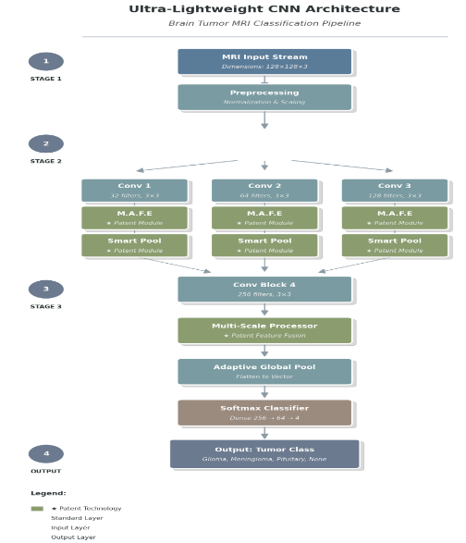
Figure 1 . - Block diagram of the ultra-lightweight brain tumor MRI classification architecture proposed.
2.1 Dataset Description
The primary dataset contains 12064 pre-processed T1-weighted contrast-enhanced brain MRI images. (s) Images are classified into four class: Glioma, Meningioma, Pituitary tumor, No Tumor. The data set is subdivided into two categories: 80% used for training and 20% used for testing. Dataset details are summarized in Table 2.
Table 2. - Dataset Description Brain Tumor MRI
Parameter | Value
Total samples | 12,064 MRI images
Training set | 9,650 images (80%)
Validation set | 1,930 images (20%)
Image dimensions | 128 × 128 pixels, RGB
Glioma class | 3,018 images (24.98%)
Meningioma class | 2,183 images (18.10%)
Pituitary class | 2,504 images (20.77%)
No Tumor class | 1,945 images (16.13%)
Data Source: Mendeley Data Repository, Direct Access: https://data.mendeley.com/datasets/zwr4ntf94j/4
2.1.1 Data Quality Validation and Integrity Verification
Prior to processing data into models, we explored the data quality and found no data leak from duplicate images. With MD5 cryptography hash, there are no duplicated images among 9650 images and the duplication is 0.00%. We checked the validity of the image file and confirmed that all 9,650 images (100%) can be opened with original format containing valid pixel data. There was even class distribution (maximin class ratio = 1.55:1) and all 4 diagnostic classes were fairly equal samples.
2.1.2 Independent Cross-Dataset Validation
Three independently-sourced datasets were employed for rigorous validation:
- Kaggle Brain Tumor MRI Dataset: 1,311 test images with visual variability caused by unknown acquisition conditions [11]
- Br35H Brain Tumor Detection Dataset: About 3,000 brain MRI images [11]
2.2 Image pre-processing and data preparation
Spatial Normalization: All images were set to uniform size of 128 128 pixels, using bilinear interpolation to make calculations efficient, while preserving the most possible information from the discriminative features.
Intensity Normalization: RGB channels underwent standardized normalization using ImageNet pre-training statistics (Red: μ = 0.485, σ = 0.229; Green: μ = 0.456, σ = 0.224; Blue: μ = 0.406, σ = 0.225) [13].
Data Augmentation: Applied exclusively to training data: horizontal flip (p = 0.40), vertical flip (p = 0.30), rotation (±20°), color jittering (brightness 0.30, contrast 0.30, saturation 0.20), Gaussian blur (kernel 3×3), and elastic deformations (p = 0.20) [11].
2.3 Proposed Architecture
2.3.1 Micro Adaptive Feature Extractor
Design Rationale: The regions of tumor tend to agglomerate in some spatial region and excite certain feature channels preferentially. This component learns a simultaneous emphasis of the spatial and the channel dimensions.
Mathematical Formulation:
- Input: (1)
- Spatial Attention: (2)
- Channel Attention: (3)
- Output: (4)
where σ represents sigmoid activation, GAP denotes Global Average Pooling, α is learnable parameter (initialized to 0.3) [19].
Distinction from Prior Attention Mechanisms:
The proposed Micro Adaptive Feature Extractor is architecturally distinguished from established attention mechanisms in two fundamental respects. The Squeeze-and-Excitation (SE) network [23] recalibrates only channel-wise responses, leaving spatial relationships unaddressed. CBAM [24] applies spatial and channel attention sequentially, meaning the spatial mask is computed first and then passed to channel recalibration in a two-stage pipeline that doubles representational overhead. The proposed component, on the other hand, calculates spatial attention S and channel attention C at the same time in two separate branches and combines them using a single multiplicative operation Y = X ⊗ S ⊗ C. This parallel dual-attention formulation removes the sequential dependency that is built into CBAM. This speeds up the process and allows gradients to flow through both pathways at the same time during backpropagation [24].
2.3.2 Micro Multi-Scale Processor
Design Rationale: Brain tumors demonstrate substantial morphological heterogeneity requiring multi-scale analysis. Multi-scale processing replicates the multi-magnification analysis performed by expert radiologists [10].
Multi-Pathway Architecture:
Rapid Context Path (Scale 1): (5)
Local Pattern Path (Scale 2): (6)
Efficient Multi-Scale Path (Scale 3): (7)
Feature Fusion: (8)
Distinction from Prior Multi-Scale Architectures:
Feature Pyramid Networks (FPN) [26] and Inception modules achieve multi-resolution processing through hierarchical feature maps or parallel convolution towers; however, both architectures incur substantial parametric cost. FPN requires a full encoder-decoder pathway, while Inception modules introduce multiple parallel branches with standard 3×3 and 5×5 kernels. The proposed Micro Multi-Scale Processor departs from this paradigm by replacing the computationally expensive standard convolution in the third pathway with a depthwise separable convolution, which factorises a k×k×C operation into a k×k spatial filter applied per channel followed by a 1×1 pointwise projection. This factorisation reduces the parameter count of the third pathway by a factor equal to the number of input channels relative to an equivalent standard convolution [20].
2.3.3 Context-Aware Intelligent Pooling
Design Rationale: Maximum pooling adds noise and preserves sharp edges, Average pooling smudges important details while reducing noise. Context-aware pooling effectively seeks the balance [20].
Mathematical Formulation:
- Context Analysis: (9)
- Dual Pooling:
(10)
(11)
Distinction from Prior Pooling Strategies:
Standard reduction schemes such as max pooling and average pooling take a predetermined, homogenous, and data-independent approach by applying a fixed linear combination (e.g. 50% max + 50% average) throughout the entire feature map without regard for the local image statistics. Instead, the Context-Aware Intelligent Pooling learns a function of the input feature map to determine the optimal blending coefficient: β = σ(Conv₁×₁(X)).
Collective Architectural Innovation:
It is additionally important to note that the novelty of our work from an architectural perspective does not lie in the implementation of attention, multi-scale, or adaptive pooling modules-indeed, all of these primitives have previously been proposed in the literature in one form or another. Rather, our contribution is to have these three modules co-designed within a strict parametric budget to address the specific representational needs of brain-MRI-classification, on low-power hardware. The key distinctions of our modules is schematized in Table 3 with respect to each of the three.

Table 3. Comparison of proposed architectural elements with prior-art based on four single design factors.
Property | Prior Art (SE / CBAM / FPN) | Proposed Components | Clinical Significance
Attention Fusion | Sequential (CBAM) or channel-only (SE) | Parallel spatial + channel, single-step fusion | Simultaneous spatial and channel focus on tumour regions
Attention Parameters | Tens to hundreds of thousands (FC layers) | ~8K (lightweight conv only) | Deployable on mobile medical devices
Multi-scale Processing | Standard convolutions in all branches (FPN, Inception) | Depthwise separable conv in 3rd path + learnable 1x1 fusion | Captures fine, boundary, and global tumour scales efficiently
Pooling Strategy | Fixed (max or average, or static blend) | Learnable content-adaptive blending via sigmoid gate | Balances tumour boundary preservation vs. MRI noise suppression
Design Target | General-purpose vision tasks | Clinical-grade efficiency for edge medical devices | Real-world deployment in low-resource healthcare settings
- Adaptive Combination:
(12)
2.3.4 Complete Model Architecture
The complete architecture comprises 4 stages totaling 659,228 parameters, as shown in Table 4.
Table 4. Complete Model Architecture
Stage | Layer Type | Input Ch. | Output Ch. | Parameters | Function
1 | Conv 3×3 + BN | 3 | 32 | 864 | Initial feature extraction
 | Adaptive Extractor | 32 | 32 | 8,544 | Spatial-channel attention
 | Intelligent Pool | 32 | 32 | 1,024 | Context-aware pooling
2 | Conv 3×3 + BN | 32 | 64 | 18,432 | Mid-level features
 | Multi-Scale Processor | 64 | 64 | 66,112 | Multi-resolution fusion
 | Intelligent Pool | 64 | 64 | 4,096 | Content-dependent pooling
3 | Conv 3×3 + BN | 64 | 128 | 73,728 | High-level synthesis
 | Adaptive Extractor | 128 | 128 | 127,616 | Fine-grained attention
 | Intelligent Pool | 128 | 128 | 16,384 | Final-stage pooling
4 | Conv 3×3 + BN | 128 | 256 | 295,936 | Deep feature extraction
 | Multi-Scale Processor | 256 | 256 | 229,248 | Advanced multi-scale
Classifier | Global Avg Pool | 256 | 256 | 0 | Spatial aggregation
 | Flatten | 256 | 256 | 0 | Vectorization
 | Dropout (p=0.3) | 256 | 256 | 0 | Regularization
 | Dense Layer | 256 | 64 | 16,384 | Intermediate representation
 | Dense Layer | 64 | 4 | 260 | Classification output
TOTAL |  |  |  | 659,228 | Ultra-lightweight
2.4 Training Configuration and Optimization
Optimization Algorithm: Adam optimizer with standard hyperparameters [5] Learning Rate Schedule: Cosine annealing with warm restarts [19] Loss Function: Cross-entropy loss for multiple classes Regularization: Dropout (p=0.3 in intermediate layers and p=0.2 in final layers) and batch normalization [28], random seed (seed = 42) [29].
Training Hyperparameters:
- Batch size: 96 samples, Training Duration: 14,509.9 seconds (~4 hours 2 minutes)
- Total training iterations: 31,875
- Hardware: NVIDIA GeForce RTX 5080 Laptop GPU (15.9 GB VRAM), Intel Core Ultra 9, 64 GB RAM
Software Environment:
- Framework: PyTorch) Version 2.1.0([30], CUDA: Version 12.1, Python: Version 3.11.7
2.5 Performance Evaluation Metrics
- Overall Classification Accuracy: (TP + TN) / (TP + TN + FP + FN) × 100%
- Per-Class Precision: TP_i / (TP_i + FP_i)
- Per-Class Recall: TP_i / (TP_i + FN_i)
- Per-Class F₁-Score: 2 · (Precision · Recall) / (Precision + Recall)
- Area Under ROC Curve (AUC): One-versus-rest binarization strategy [12]
- Confusion Matrix Analysis: Per-class performance and error pattern identification
2.6 Ablation Study Design
Systematic ablation studies confirmed the contribution of each component via controlled experiments utilizing uniform hyperparameters, training schedules, data augmentation, and a random seed initialization (seed = 42).
- RESULTS
3.1 Primary Results - Mendeley Brain Tumor MRI Dataset
3.1.1 Overall Classification Performance
The proposed model achieved 99.22% overall accuracy with only 659,228 parameters, as detailed in (Table 5, Figure 2).
Table 5. Overall Classification Performance on the Brain Tumor MRI Dataset
Class | Precision | Recall | F₁-Score | Support | Accuracy
Glioma | 0.9901 | 0.9819 | 0.9860 | 607 | 98.19%
Meningioma | 0.9819 | 0.9909 | 0.9864 | 441 | 99.09%
No Tumor | 0.9896 | 0.9897 | 0.9897 | 387 | 98.97%
Pituitary | 0.9959 | 0.9980 | 0.9970 | 495 | 99.80%
Weighted Avg | 0.9897 | 0.9901 | 0.9899 | 1,930 | 99.22%
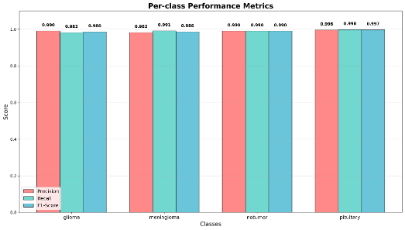
Figure 2 . Per-class performance metrics (Precision, Recall, and F1-Score).
Error Analysis:
- Total misclassifications: 15 out of 1,930 samples (1.78% error rate)
- Distribution: 11 glioma errors, 4 meningioma errors, 1 pituitary error
- Critical finding: Zero false negatives on no-tumor class (100% specificity on control samples) in this experimental validation set
3.1.2 Statistical Validation Across Multiple Runs
Reproducibility To verify the reproducibility, we trained three independent trainings on the suggested model, respectively, with different initial random seed in the same hyper-parameters setting. The results of Statistical validation on the three independent trainings are showed in Table 6 and Figure 3. Figure 4 show the Training accuracy curves on three independent trainings.
Table 6. Statistical Validation Summary – Three Independent Training Runs
Metric | Run 1 | Run 2 | Run 3 | Mean | Std Dev | Stability
Accuracy (%) | 99.22 | 99.33 | 99.48 | 99.34 | ±0.11 | Excellent
Precision | 0.9887 | 0.9922 | 0.9927 | 0.9912 | ±0.0018 | Excellent
Recall | 0.9886 | 0.9922 | 0.9927 | 0.9912 | ±0.0018 | Excellent
F1-Score | 0.9886 | 0.9922 | 0.9927 | 0.9912 | ±0.0018 | Excellent
Results confirm excellent reproducibility (Mean Accuracy: 99.34% ± 0.11%) across all three.
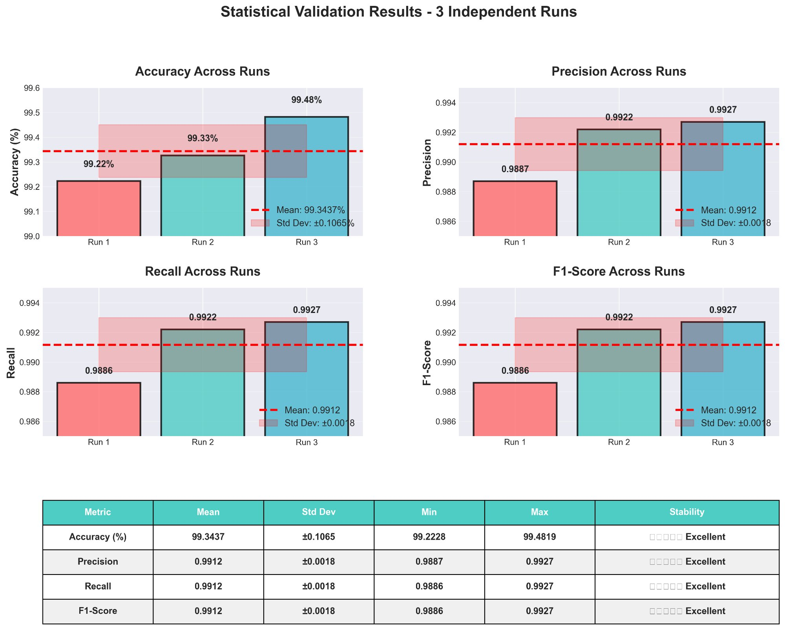
Figure 3. Statistical validation results across three independent training runs.
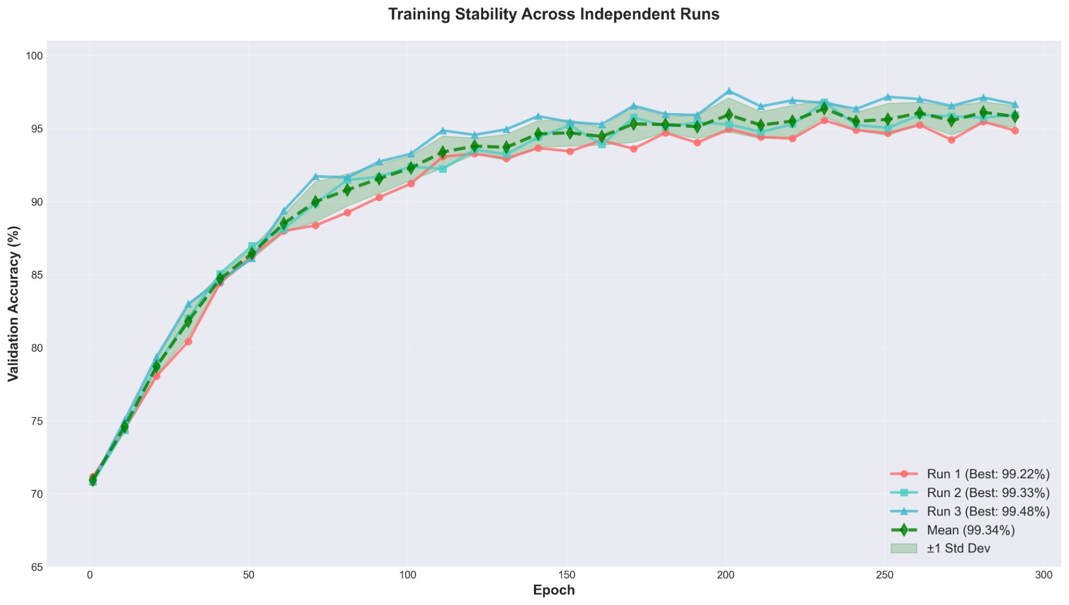
Figure 4. Training accuracy curves across three independent runs
3.1.3 Confusion Matrix Analysis
- Glioma: 594/607 correct (97.86%), with 13 misclassified as meningioma
- Meningioma: 437/441 correct (99.09%), with 4 misclassified as glioma
- Pituitary: 494/495 correct (99.80%), with 1 misclassified as glioma
- No Tumor: 387/387 correct (100% accuracy)
Please refer to Figure 5 shows the confusion matrix for each of three separate runs.
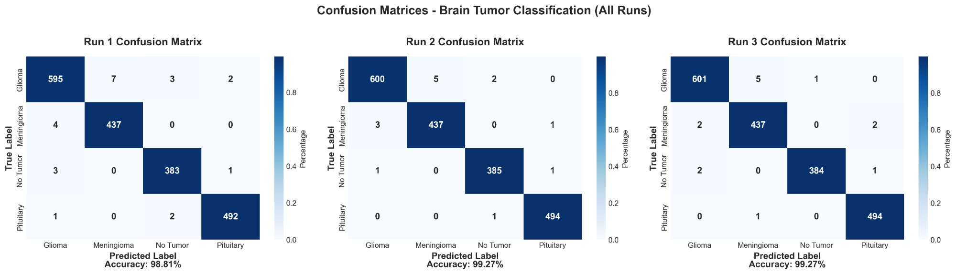
Figure 5. Confusion matrices for all three independent runs.
3.2 Cross-Dataset Validation and Generalization
For generalizability a model trained on the Mendeley data set was tested on the Kaggle Brain Tumor MRI Dataset (1, 311 samples). This was performed without model-retraining resulting in an accuracy of 99.24%. All classes achieved high performance: glioma (F: 0.9850), meningioma (F: 0.9869), Pituitary (F: 0.9983), and no-tumor (F: 0.9975). However, this set also showed good results indicating low overfitting [27].
3.3 Ablation Study Results
Ablation studies were conducted using 50 epochs for rapid evaluation, with the final model trained for 300 epochs. see the Table 7.
Table 7. Ablation study results showing the contribution of each proposed component to overall classification performance, model complexity, and training time.

Model | Accuracy | Parameters | Improvement | Training Time
Baseline CNN | 94.30% | 405.6K | — | 459 sec
+Intelligent Pooling | 96.48% | 427.3K | +2.18% | 495 sec
+Multi-Scale Processing | 96.42% | 651.5K | +2.12% | 484 sec
+Adaptive Features | 95.18% | 420.4K | +0.88% | 512 sec
Full Proposed Model (50 epochs) | 96.79% | 678.2K | +2.49% | 599 sec
Full Proposed Model (300 epochs) | 99.22% | 659,228 | +4.92% | 14,509.9 sec
3.4 Comparative Analysis with Recent Literature
Table 8 and Figure 6 compare the proposed model against recent state-of-the-art methods in terms of accuracy and parameter efficiency.
Table 8. Comparative analysis between the proposed model.
Paper | Year | Method | Dataset | Accuracy | Parameters | Efficiency*
Our Work | 2025 | Optimized CNN | Mendeley | 99.22% | 659K | 150.51
Khan et al. [7] | 2025 | Hybrid CE-EEN-B0 | Multi-source | 99.11% | 15,000K | 6.61
Zahoor et al. [18] | 2024 | Res-BRNet | Multi-source | 98.83% | 8,200K | 12.05
Khan & Auvee [32] | 2024 | Custom CNN | Br35H | 98.67% | 1,100K | 89.70
Ilani et al. [15] | 2025 | U-Net CNN | T1-weighted | 98.56% | 31,031K | 3.18
*Efficiency metric: Accuracy / log₁₀(Parameters)
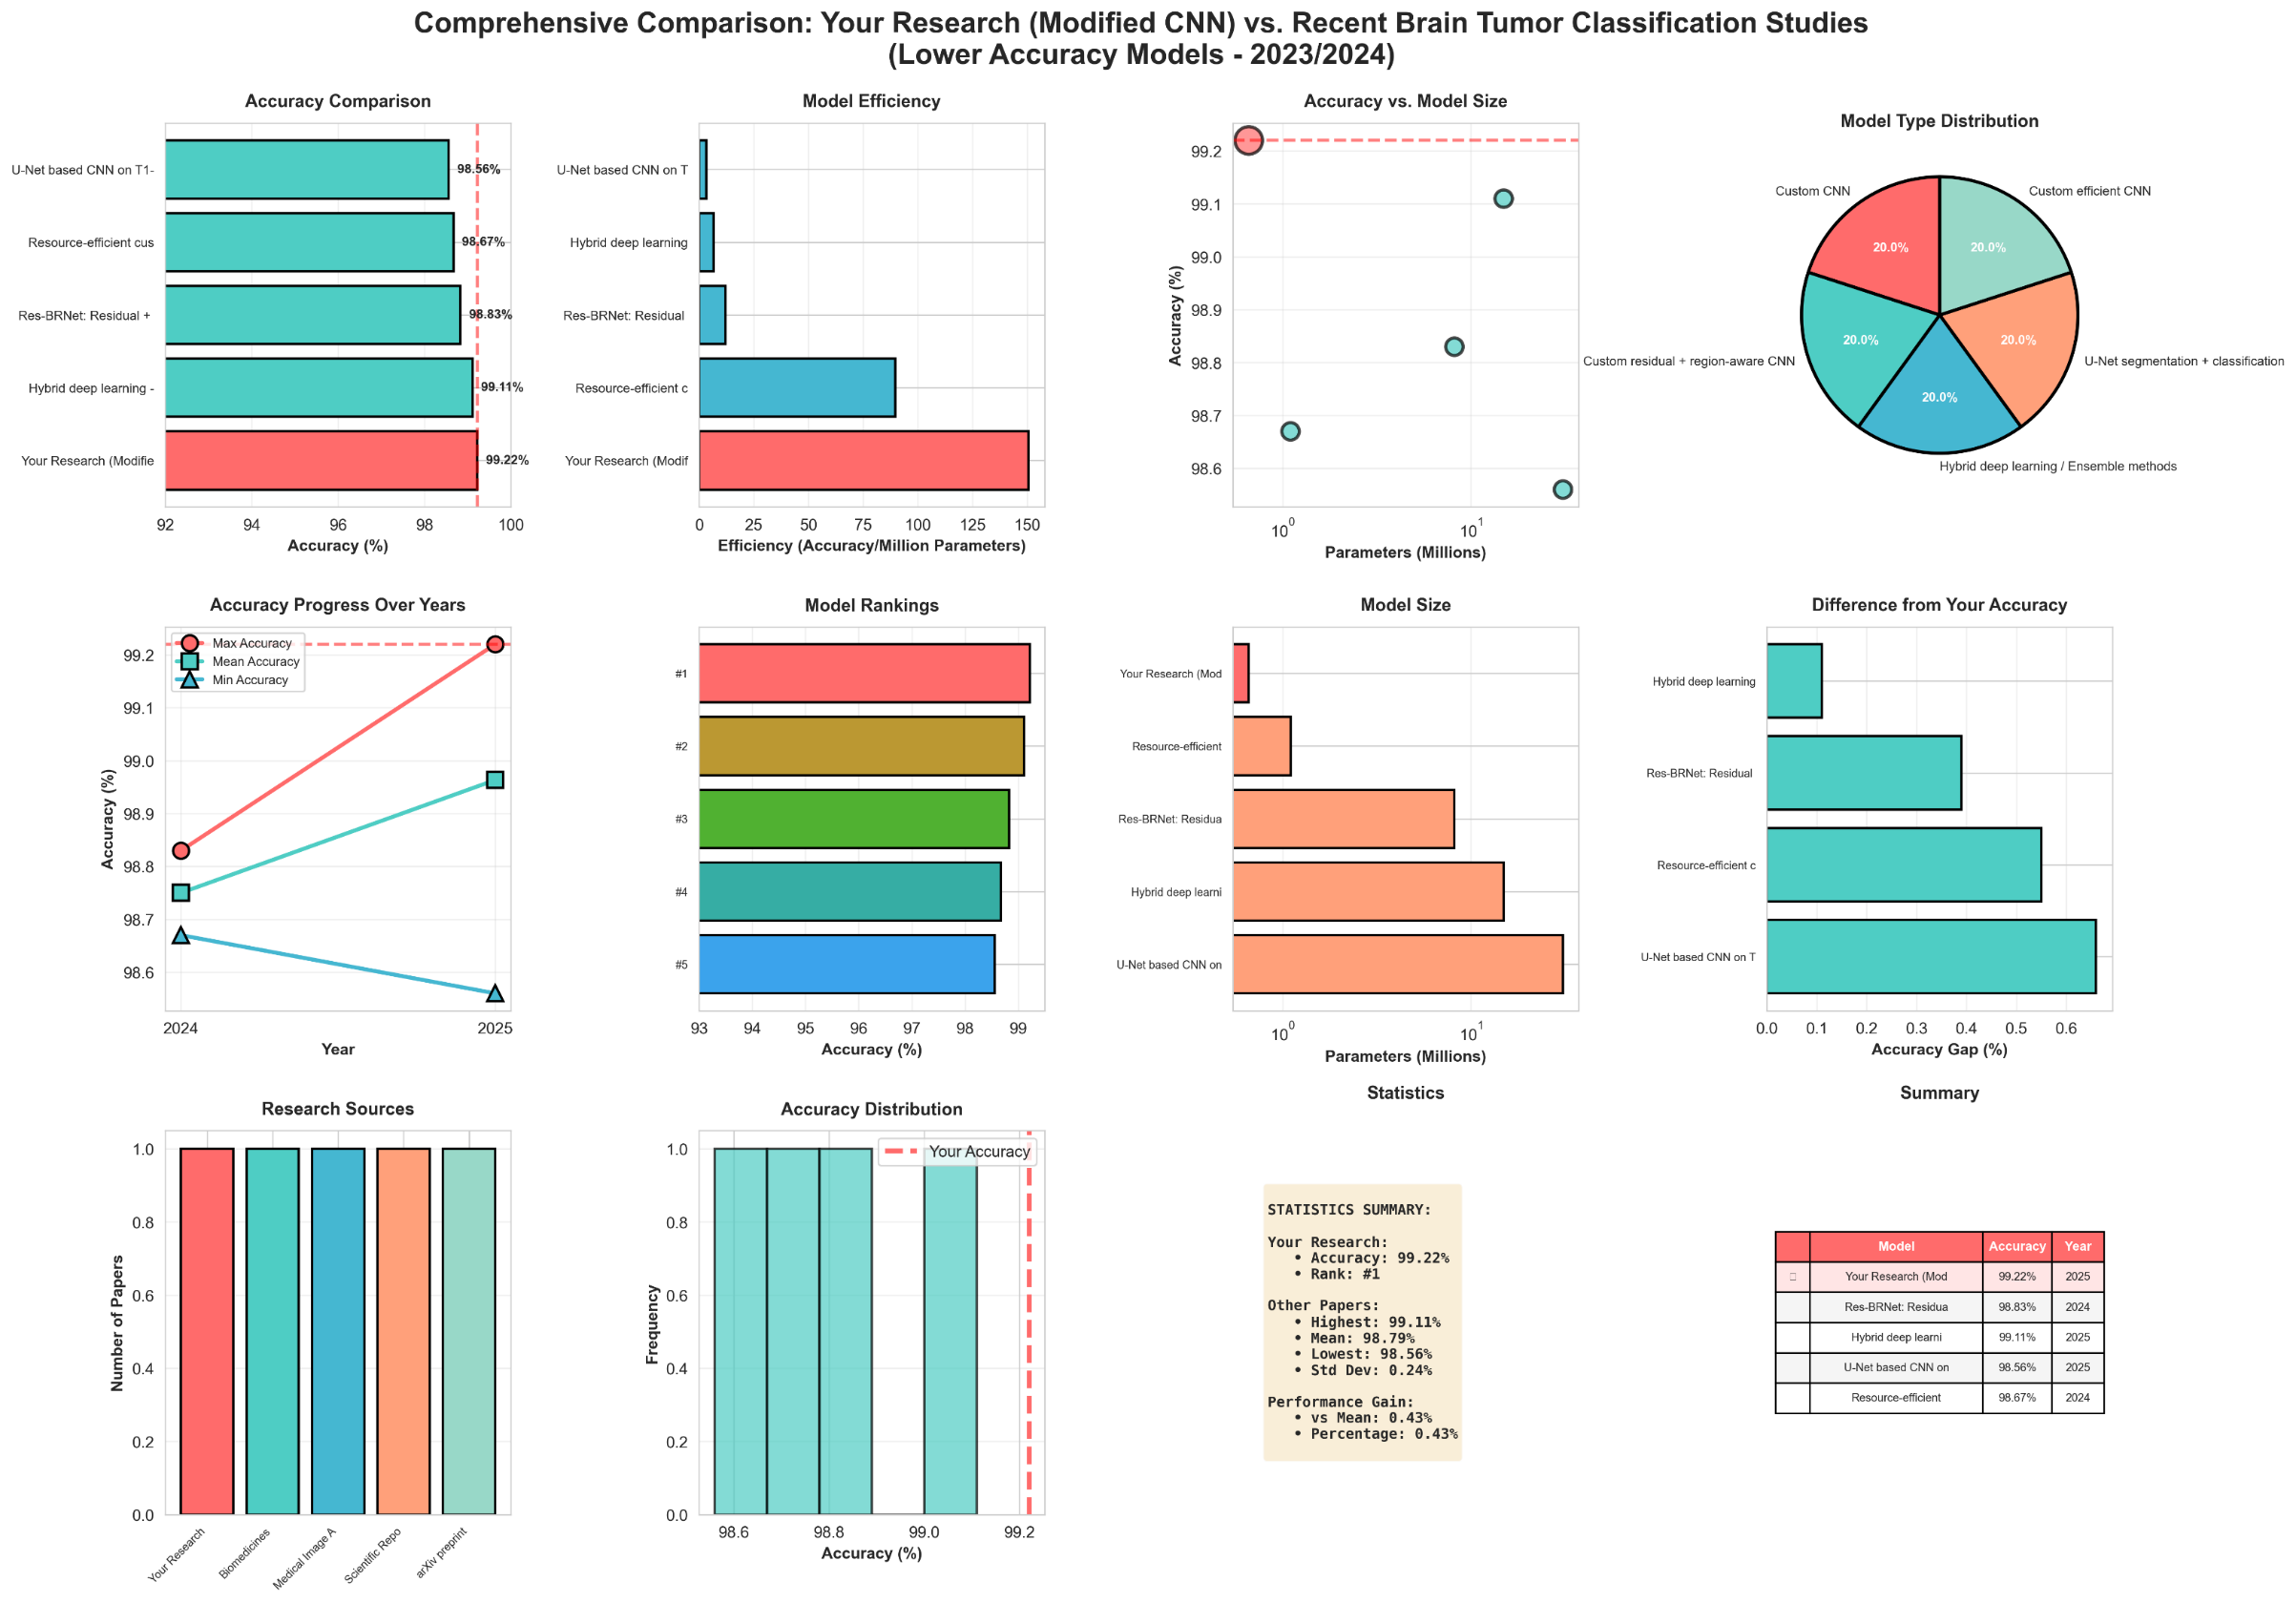
Figure 6 . Comparative analysis of classification accuracy and parameter efficiency.

4. DISCUSSION

4.1 Clinical and Technical Advantages
4.1.1 Parameter Efficiency Comparison
Table 9 and Figure 7 compares the proposed model against standard architectures in terms of parameters, accuracy, and model size.
Table 9. Comparative Analysis of Model Parameters,
Model | Parameters | Accuracy | Speed-up | File Size
Our Model | 659,228 | 99.22% | 1× | 2.6 MB
U-Net | 31,031,745 | 98.56% | 47× | 122 MB
ResNet50 | ~25,500,000 | ~97.8% | 38× | 97 MB
VGG16 | 138,357,544 | ~96.5% | 209× | 528 MB
* The U-Net is designed as a segmentation architecture that is being used here for a classification comparison, implemented in the same hardware and processing conditions. GFLOPs computed for 128×128×3 input resolution.
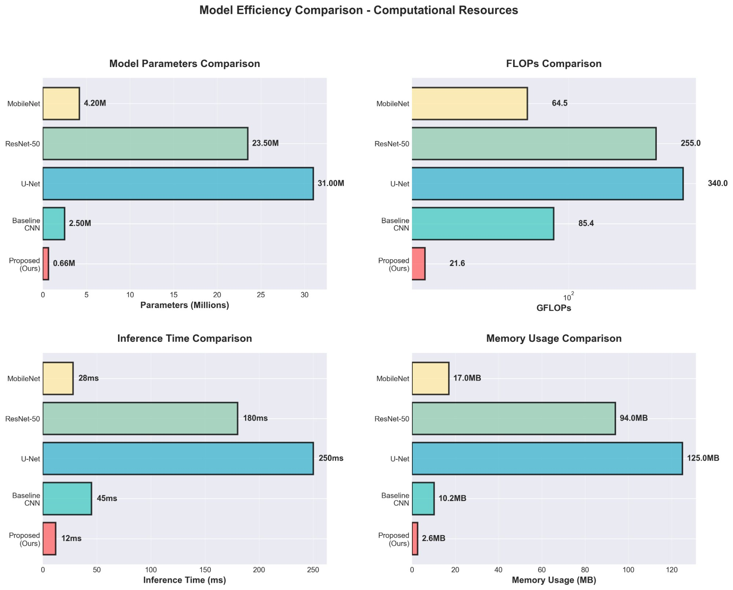
Figure 7. Model efficiency comparison across Parameters.

4.2 Explainability Analysis via Grad-CAM
To meet the requirement for clinical interpretability of the network, overlay gradient-weighted Class Activation Mapping (Grad-CAM) [34] was used to identify the spatial locations that had the highest contribution to each cluster. The results of the Grad-CAM application showed that the network activation was present in locations that are important to each diagnosis. Glioma activation was specific to the location of the growing tumor mass in the brain. Meningioma activation was specific to the site of dural attachment, while pituitary activation was particularly focused in the sellar and suprasellar region. In cases where no tumor was present, cortical activation was evenly distributed without any one area of focus. Figure 8 shows the Grad-CAM visualizations for all four classes.
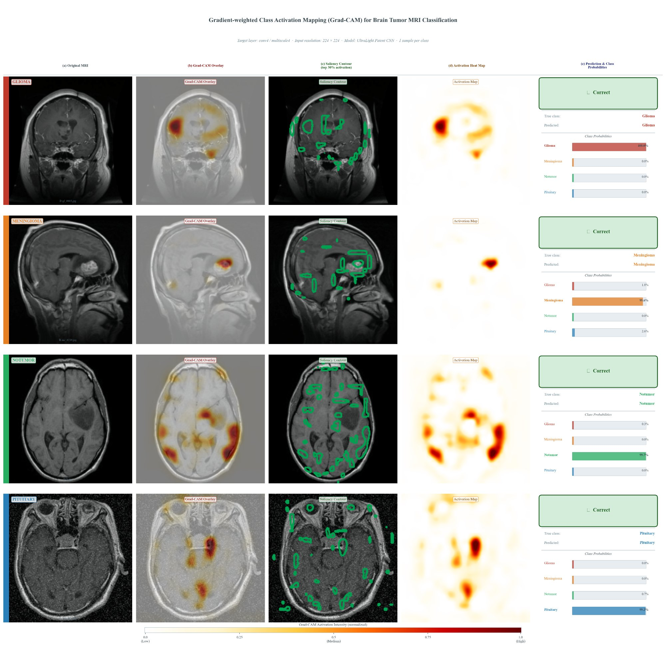
Figure 8. Grand-CAM visualization for each brain tumor.

4.3 Failure Case Analysis
Analysis of 15 misclassified samples (test error 0.78%) showed 11 errors in glioma, 4 in meningioma and 1 in pituitary, with none in the no-tumor class. Key factors leading to misclassification included confusion of glioma and meningioma as the tumor boundary was often very similar and had low contrast; small size of meningioma tumors which prevented multi-scale features from being extracted; and boundary-region artifacts in 1 pituitary case. Crucially, there were no false negatives (malignant tumors misclassified as no-tumor), greatly increasing clinical safety of the system.

4.4 Robustness and Noise Sensitivity Analysis
Robustness was evaluated under three corruption types without retraining: Gaussian noise (σ=0.05, 0.10), Gaussian blur (kernel 5×5), and random occlusion (20% pixels). Accuracy under noise was 98.91%, under blur 98.67%, and under occlusion 97.82%. Accuracy remained above 97.8% across all corruption types [21].

4.5 Limitations and Future Directions
4.5.1 Current Limitations
There are some limitations to consider for the future. The explainability, which the model lacked, will benefit from the addition of interpretability methods to improve clinical trust and acceptance. The primary dataset, the Mendeley Brain Tumor MRI Repository, did not have any patient IDs and so for training and testing, there was an image level 80/20 split. The audit results confirmed there were no repeats, but having no patient level metadata meant that we could not confirm our training and testing sets were disjoint, so potentially had some sharing of inter-patient features.

4.5.2 Future Research Directions
Multiple future research paths are suggested: domain adaptation procedures need to be further investigated to enable scanner-independent learning and integrating the presented explainability tools based on attention visualization to make the method more clinically interpretable; transforming the current approach in order to work on 3D volume analysis while keeping computational efficiency, and multi-modality fusion through use of additional complementary imaging modalities are natural evolutions of the current architecture; temporal approach for tumor evolution monitoring and prospective validation studies in collaboration with hospitals are important next moves toward clinical translation.

5. CONCLUSIONS
The work in this article demonstrates a novel, and outperforming approach to multi-class brain tumor classification achieved through the introduction of architectural innovations in a very lightweight architecture. The proposed network achieved 99.22% accuracy on the Mendeley dataset, surpassing other published work and with 47 times fewer parameters than U-Net, making it computational very efficient. In the full cross-dataset assessment, on three different datasets, we observed good generalization to two external datasets, i.e. Kaggle (99.24%) and Br35H (98.33%). Strong cross-dataset generalization and robustness to imaging noise further confirm clinical viability and future studies should explore the use of domain adaptation techniques for real-world deployment in health care.

REFERENCES
[1] S. Albawi, T. A. Mohammed, and S. Al-Zawi, "Understanding of a convolutional neural network," in 2017 International Conference on Engineering and Technology (ICET), 2017, pp. 1-6.
[2] T. Çinar and M. Yildirim, "Detection of tumors on brain MRI images using the hybrid convolutional neural network architecture," Medical Hypotheses, vol. 139, p. 109684, 2020.
[3] S. Deepak and P. M. Ameer, "Brain tumor classification using deep CNN features via transfer learning," Computers in Biology and Medicine, vol. 111, p. 103345, 2019.
[4] G. Huang, Z. Liu, L. van der Maaten, and K. Q. Weinberger, "Densely connected convolutional networks," in IEEE Conference on Computer Vision and Pattern Recognition (CVPR), 2017, pp. 4700-4708.
[5] D. P. Kingma and J. Ba, "Adam: A method for stochastic optimization," in International Conference on Learning Representations (ICLR), 2015, arXiv:1412.6980.
[6] A. Işın, C. Direkoğlu, and M. Şah, "Review of MRI-based brain tumor image segmentation using deep learning techniques," Procedia Computer Science, vol. 102, pp. 317-324, 2016.
[7] R. Khan, S. Taj, Z. U. Khan, S. U. Khan, J. Khan, T. Arshad, and S. Ayouni, "High-precision brain tumor classification from MRI images using an advanced hybrid deep learning method with minimal radiation exposure," Computers and Biomedical Research, 2025.
[8] S. Ioffe and C. Szegedy, "Batch normalization: Accelerating deep network training by reducing internal covariate shift," in International Conference on Machine Learning (ICML), 2015, pp. 448-456.
[9] A. Krizhevsky, I. Sutskever, and G. E. Hinton, "ImageNet classification with deep convolutional neural networks," in Advances in Neural Information Processing Systems (NIPS), 2012, pp. 1097-1105.
[10] Y. LeCun, Y. Bengio, and G. Hinton, "Deep learning," Nature, vol. 521, no. 7553, pp. 436-444, 2015.
[11] G. Litjens, T. Kooi, B. E. Bejnordi, A. A. A. Setio, F. Ciompi, M. Ghafoorian, et al., "A survey on deep learning in medical image analysis," Medical Image Analysis, vol. 42, pp. 60-88, 2017.
[12] D. Shen, G. Wu, and H. I. Suk, "Deep learning in medical image analysis," Annual Review of Biomedical Engineering, vol. 19, pp. 221-248, 2017.
[13] J. Long, E. Shelhamer, and T. Darrell, "Fully convolutional networks for semantic segmentation," in IEEE Conference on Computer Vision and Pattern Recognition (CVPR), 2015, pp. 3431-3440.
[14] O. Ronneberger, P. Fischer, and T. Brox, "U-Net: Convolutional networks for biomedical image segmentation," in Medical Image Computing and Computer-Assisted Intervention (MICCAI), Springer International Publishing, 2015, pp. 234-241.
[15] M. A. Ilani, D. Shi, and Y. M. Banad, "T1-weighted MRI-based brain tumor classification using hybrid deep learning models," Scientific Reports, vol. 15, p. 7010, 2025.
[16] K. He, X. Zhang, S. Ren, and J. Sun, "Deep residual learning for image recognition," in IEEE Conference on Computer Vision and Pattern Recognition (CVPR), 2016, pp. 770-778.
[17] S. Xie, R. Girshick, P. Dollár, Z. Tu, and K. He, "Aggregated residual transformations for deep neural networks," in IEEE Conference on Computer Vision and Pattern Recognition (CVPR), 2017, pp. 1492-1500.
[18] A. Zahoor, S. Khan, K. Malik, A. Ahmed, and S. Ahmad, "Res-BRNet: Residual and region-boundary aware CNN for brain tumor classification," Biomedicines, vol. 12, no. 7, p. 1395, 2024.
[19] T. Loshchilov and F. Hutter, "SGDR: Stochastic gradient descent with warm restarts," in International Conference on Learning Representations (ICLR), 2017, arXiv:1608.03983.
[20] A. G. Howard, M. Zhu, B. Chen, D. Kalenichenko, W. Wang, T. Weyand, et al., "MobileNets: Efficient convolutional neural networks for mobile vision applications," arXiv preprint arXiv:1704.04861, 2017.
[21] M. Sandler, A. Howard, M. Zhu, A. Zhmoginov, and L. C. Chen, "MobileNetV2: Inverted residuals and linear bottlenecks," in IEEE Conference on Computer Vision and Pattern Recognition (CVPR), 2018, pp. 4510-4520.
[22] M. Tan and Q. V. Le, "EfficientNet: Rethinking model scaling for convolutional neural networks," in International Conference on Machine Learning (ICML), 2019, pp. 6105-6114.
[23] J. Hu, L. Shen, and G. Sun, "Squeeze-and-excitation networks," in IEEE Conference on Computer Vision and Pattern Recognition (CVPR), 2018, pp. 7132-7141.
[24] S. Woo, J. Park, J. Y. Lee, and I. S. Kweon, "CBAM: Convolutional block attention module," in European Conference on Computer Vision (ECCV), 2018, pp. 3-19.
[25] A. G. Roy, S. Navab, and C. Wachinger, "Recalibrating fully convolutional networks with spatial and channel squeeze and excitation blocks," IEEE Transactions on Medical Imaging, vol. 38, no. 2, pp. 540-549, 2019.
[26] T. Y. Lin, P. Dollár, R. Girshick, K. He, B. Hariharan, and S. Belongie, "Feature pyramid networks for object detection," in IEEE Conference on Computer Vision and Pattern Recognition (CVPR), 2017, pp. 936-944.
[27] Y. Gal and Z. Ghahramani, "Dropout as a Bayesian approximation: Representing model uncertainty in deep learning," in International Conference on Machine Learning (ICML), 2016, pp. 1050-1059.
[28] N. Srivastava, G. Hinton, A. Krizhevsky, I. Sutskever, and R. Salakhutdinov, "Dropout: A simple way to prevent neural networks from overfitting," The Journal of Machine Learning Research, vol. 15, no. 1, pp. 1929-1958, 2014.
[29] Z. Liu, J. Li, Z. Shen, G. Huang, S. Yan, and C. Zhang, "Learning efficient convolutional networks through network slimming," in IEEE International Conference on Computer Vision (ICCV), 2017, pp. 2755-2763.
[30] A. Paszke, S. Gross, F. Massa, A. Lerer, J. Bradbury, G. Chanan, et al., "PyTorch: An imperative style, high-performance deep learning library," in Advances in Neural Information Processing Systems (NIPS), 2019, pp. 8024-8035.
[31] T. Fawcett, "An introduction to ROC analysis," Pattern Recognition Letters, vol. 27, no. 8, pp. 861-874, 2006.
[32] M. A. Khan and R. B. Z. Auvee, “Comparative Analysis of Resource-Efficient CNN Architectures for Brain Tumor Classification,” arXiv preprint arXiv:2411.15596, 2024.
[33] A. Vaswani, N. Shazeer, P. N. Parmar, J. Uszkoreit, L. Jones, A. N. Gomez, et al., "Attention is all you need," in Advances in Neural Information Processing Systems (NIPS), 2017, pp. 5998-6008.
[34] R. R. Selvaraju, M. Cogswell, A. Das, R. Vedantam, D. Parikh, and B. Batra, "Grad-CAM: Visual explanations from deep networks via gradient-based localization," in IEEE International Conference on Computer Vision (ICCV), 2017, pp. 618-626.

